

FACULTY OF TECHNOLOGY AND ENGINEERING
DEVANG PATEL INSTITUTE OF ADVANCE TECHNOLOGY
AND RESEARCH

DEPARTMENT OF COMPUTER ENGINEERING

A.Y 2026 – 27 Semester – 3

LAB MANUAL

CSUC201 Fundamentals of Data Structures and Algorithms


Practical 9: Graph Traversal: Depth-First Search and Breadth-First Search
Practical Aim
To implement depth-first and breadth-first traversal on a graph and develop the ability to reason about how the order of exploration changes depending on the traversal strategy used.
Problem 1
A disaster relief team needs to inspect all buildings in a city after an earthquake. The city is mapped as a network where buildings are connected by roads. One team starts at a building and goes as deep into each road as possible before backtracking, while a second team spreads out level by level — first checking all buildings directly connected to the start, then all buildings two roads away, and so on. Given the city map as a graph and a starting building, implement both exploration strategies and print the order in which buildings are visited by each team.
Describe how the order of buildings visited differs between the two strategies on the same graph. What data structure does each strategy rely on to decide which building to visit next, and how does that structure cause the difference in order?
Theory:
- Both strategies visit every reachable node exactly once. If the goal is simply to check whether a specific building exists in the network, which strategy would find it sooner if the building is very close to the start? What if it is very far and deep? Explain your reasoning without tracing through any specific example.
If the target is close to the starting building, BFS may find it sooner because it explores all directly connected buildings before moving farther away. If the target is very far and deep along a particular path, DFS may find it sooner if it explores that path first. However, DFS does not guarantee this because its performance depends on the order in which neighbouring buildings are explored.
2. Your DFS implementation likely uses recursion. What real-world constraint on the computer could cause your recursive DFS to fail on a very large city map, and how would you restructure your solution to avoid that failure?
Recursive DFS can fail on a very large graph because each recursive call uses stack memory. If the path is too deep, the program may exceed the available call stack and cause a stack overflow. This can be avoided by implementing DFS iteratively using an explicit stack instead of relying on recursive function calls.

Code: https://github.com/kanan2007s-sys/FDSA_B/tree/main/Practical%201

Screenshot:
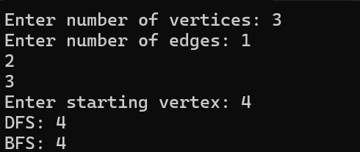
Description:
This program implements DFS and BFS graph traversal using an adjacency matrix. DFS explores vertices deeply before backtracking, while BFS visits vertices level by level using a queue. Both methods print the order of visited vertices from the given starting vertex.
Challenge:
Understanding the difference between DFS and BFS traversal methods.
Managing the visited array to avoid visiting the same vertex repeatedly. Implementing the correct traversal order using recursion in DFS and a queue in BFS.

Conclusion:
Successfully implemented DFS and BFS graph traversal and understood how DFS explores deeply before backtracking, while BFS visits vertices level by level using a queue.

